PHYDW501 DYNAMICS AND WAVES
LU 1: APPLY MOTION IN ORBITS
  - UNIVERSAL GRAVITATION MOTION IN ORBITS

The motion of Earth and the other bodies around the sun is called orbital motion.

During his study of the motions of the planets and of the moon, Newton discovered the fundamental character of the gravitational attraction between any two bodies.
Along with his three laws of motion, Newton published the law of gravitation in 1687. It may be stated as follows:
“Every particle of matter in the universe attracts every other particle with a force that is directly proportional to the product of the masses of the particles and inversely proportional to the square of the distance between them.”
Translating this into an equation, we have
Where:
F is the magnitude of the gravitational force on either particle,
m₁ and m₂ are their masses, r is the distance between them, and G is a fundamental physical constant called the gravitational constant. The numerical value of G depends on the system of units used.
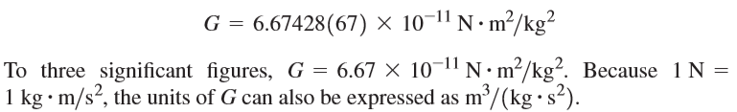
Gravitational force calculation
Let’s the mass of one of the small spheres of a Cavendish balance is 0.0100 kg, the mass of the nearest large sphere is 0.500 kg, and the center-to-center distance between them is 0.0500 m. Find the gravitational force on each sphere due to the other.
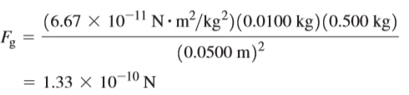
- FREE-FALL ACCELERATION AND THE GRAVITATIONAL FORCE

Weight

We deﬁned “The weight of a body is the total gravitational force exerted on the body by all other bodies in the universe.”
the weight w of a body is the force that causes the acceleration g of free fall, so by Newton’s second law, W=F = ma_{g}

- Consider an object of mass m near the Earth’s surface

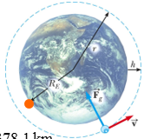
b. Consider an object of mass m at a height h above the Earth’s surface
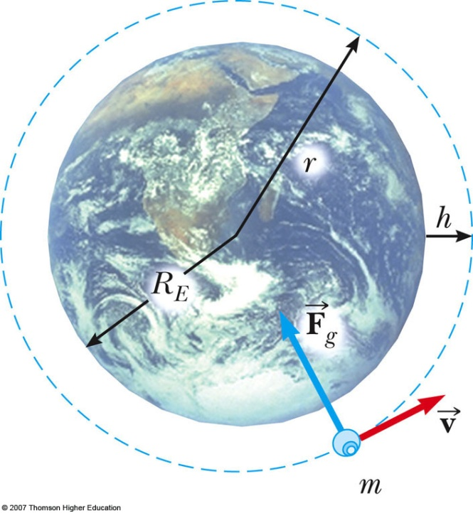
Acceleration a_{g} due to gravity
a_{g} will vary with altitude

The density of the Earth
We can measure all the quantities except m_{E}. So this relationship allows us to compute the mass m_{E} of the earth.
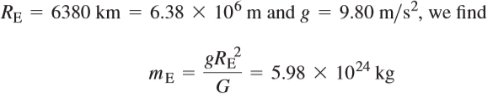
Cavendish had measured G; he computed the mass of the earth in just this way
At a point above the Earth’s surface a distance R_{E} from the center of the earth. While the earth is an approximately spherically symmetric distribution of mass, it is not uniform throughout its volume.
To demonstrate this, let’s ﬁrst calculate the average density, or mass per unit volume, of the earth. If we assume a spherical earth, the volume is
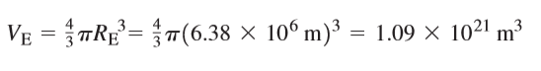
The average density (the Greek letter rho) of the earth is the total mass divided by the total volume:
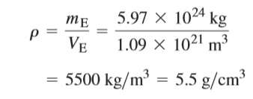
Kepler’s laws
Kepler’s First Law
“All planets move in elliptical orbits with the Sun at one focus.”
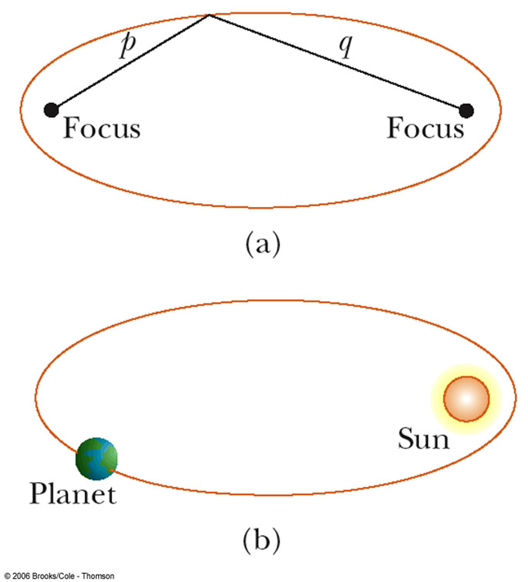

Kepler’s Second Law
“A line from the sun to a given planet sweeps out equal areas in equal times.”
Area from A to B and C to D are the same
Kepler’s Third Law
“The periods of the planets are proportional to $\frac{ 3}{2}$ the powers of the majoraxis lengths of their orbits.”
Or “The square of the orbital period of any planet is proportional to cube of the average distance from the Sun to the planet.”
or
T is the period of the planet
a is the average distance from the Sun. Or a is the length of the semi-major axis
For orbit around the Sun, K = K_{S} = 2.97x10⁻¹⁹ s²/m³
K is independent of the mass of the planet

Describe energy considerations in planetary, rocket and satellite motion
- Planetary motion
GRAVITATIONAL FIELD AND GRAVITATIONAL POTENTIAL
The gravitational field g is defined as:
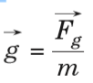
The gravitational potential V at a point is defined numerically as work done in taking a uniform mass from infinity to that point. The potential at infinity is conventionally taken as zero. Consider a unit mass which is taken from infinity to point x, i.e. at a distance r from the center of the earth.

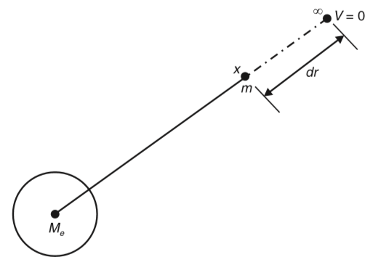 Gravitational potential at a point
let Me be the mass of the earth; The force of attraction between the earth and the mass m is:
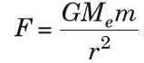
Where r is the distance of the mass from the center of the earth. The work done by gravitational force in moving a mass through a distance dr towards the earth is:
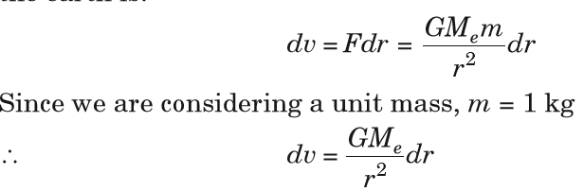
So the total work done in moving a unit mass from infinity to a point located at distance R from the center of the earth is obtained by integration:
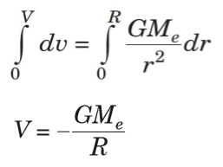
Notes :The negative sign indicates that potential at infinity is higher than potential at a point closer to the center of the earth.
ESCAPE VELOCITY FOR A PLANET
The minimum velocity with which an object can escape the gravitational pull of the planet is called Escape velocity.
If the rocket is fired from the surface of the earth with velocity v such that it just escapes from the influence of the earth’s gravitational pull, then this velocity is also called escape velocity.
Work done ( W.d.) on a mass m at the surface of the earth of mass M_{e} and radius R_{e} is:
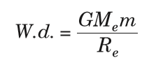

From work energy theorem, this work done equals the kinetic energy of the rocket as it escapes from the earth’s surface.
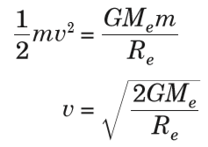

When the object of mass m is on the surface of the earth, the gravitational force equals the weight of the object;
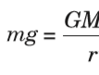
This time the distance r equals the radius of the earth Re. This gives;
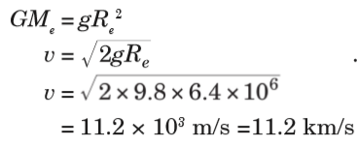
Notes: With an initial velocity about 11 km/s, a rocket will completely escape from the gravitational attraction of the earth and the velocity is independent of the mass of the rocket.

Energy Conservation in Gravitational Fields
Conservation of energy tells us that the total energy of the system is conserved, and in this case, the sum of kinetic and potential energy must be constant. This means that every change in the kinetic energy of a system must be accompanied by an equal but opposite change in the potential energy.
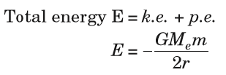
- Motion of rocket, satellite and spacecraft

ROCKETS
A rocket is a device that produces thrust by ejecting stored matter. A rocket moves forward when gas expelled from the rear of a rocket pushes it in the opposite direction.
From Newton’s laws of motion, for every action, there is an equal and opposite reaction. In a rocket, fuel is burned to make a hot gas and this hot gas is forced out of narrow nozzles in the back of the rocket, propelling the rocket forward.
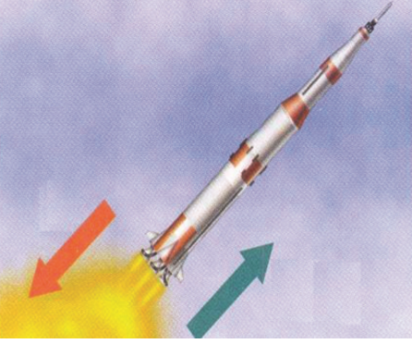
Rocket
Spacecraft Propulsion
Spacecraft Propulsion is characterized in general by its complete integration within the spacecraft (e.g. satellites). Its function is to provide forces and torques in (empty) space to:
• transfer the spacecraft: used for interplanetary travel
• position the spacecraft: used for orbit control
• orient the spacecraft: used for altitude control
The jet propulsion systems for launching rockets are also called primary propulsion systems. Spacecraft, e.g. satellites, are operated by secondary propulsion systems.
Classification of Propulsion Systems
Spacecraft propulsion can be classified according to the source of energy utilized for the ejection of propellant:
• Chemical propulsion use heat energy produced by a chemical reaction to generate gases at high temperature and pressure in a combustion chamber. These hot gases are accelerated through a nozzle and ejected from the system at a high exit velocity to produce thrust force.
• Electric propulsion uses electric or electromagnetic energy to eject matter at high velocity to produce thrust force.
• Nuclear propulsion uses energy from a nuclear reactor to heat gases which are then accelerated through a nozzle and ejected from the system at a high exit velocity to produce thrust force.

SATELLITES
A satellite is an artificial or a natural body placed in orbit round the earth or another planet in order to collect information or for communication.
Communication satellites are satellites that are used specifically to communicate.
And we’ll use them to transmit TV signals, to transmit radio signals, and in some cases, it might be to be transmit internet signals. So, all of that gets turned into radio somehow and transmitted up into space and then bounced back down somewhere else.
- Movement of satellites in orbits
The force F_{g} due to the earth’s gravitational attraction provides the centripetal acceleration that keeps a satellite in orbit.

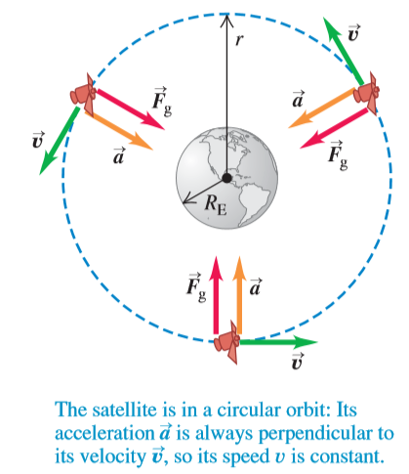
TYPES AND APPLICATIONS OF SATELLITE SYSTEMS
Four different types of satellite orbits have been identified depending on the shape and diameter of each orbit:
• GEO (Geo-stationary earth orbit)
• MEO (medium earth orbit)
• LEO (Low earth orbit) and
• HEO (Highly elliptical orbit)
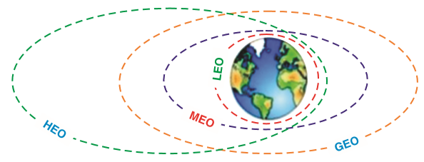

GEO (geostationary orbit)
A geostationary orbit or geosynchronous equatorial orbit (GEO) has a circular orbit 35,786 kilometres above the Earth’s equator and following the direction of the Earth’s rotation. An object in such an orbit has an orbital period equal to the Earth’s rotational period (one sidereal day) and thus appears motionless, at a fixed position in the sky, to ground observers.
Most common geostationary satellites are either weather satellites or communication satellites relaying signals between two or more ground stations and satellites that broadcast signals to a large area on the planet. All radio and TV, whether satellite etc. are launched in this orbit.
LEO (Low Earth Orbit)
Satellites in low Earth orbits are normally military reconnaissance satellites that can locate out tanks from 160 km above the Earth. They orbit the earth very quickly, one complete orbit normally taking 90 minutes. However, these orbits have very short lifetimes in the order of weeks compared with decades for geostationary satellites.
MEO (Medium Earth Orbit) or ICO (Intermediate Circular Orbit)
Medium Earth Orbit satellites move around the earth at a height of 600020000 km above earth’s surface. Their signal takes 50 to 150 milliseconds to make the round trip. MEO satellites cover more earth area than LEOs but have a higher latency. MEOS are often used in conjunction with GEO satellite systems.
HEO (Highly Elliptical Orbit)
A satellite in elliptical orbit follows an oval-shaped path. One part of the orbit is closest to the center of Earth (perigee) and another part is farthest away (apogee). A satellite in this type of orbit generally has an inclination angle of 64 degrees and takes about 12 hours to circle the planet. This type of orbit covers regions of high latitude for a large fraction of its orbital period.
COSMIC VELOCITY (FIRST, SECOND AND THIRD)
The cosmic velocity is the initial velocity which a body must have to be able to overcome the gravity of another object. We have:
1. The first cosmic velocity
2. Second cosmic velocity (escape velocity)
3. The third cosmic velocity
4. The fourth cosmic velocity
1. The first cosmic velocity
The first cosmic velocity is known as the orbital velocity, which is the least velocity of a projectile to keep the orbit around a celestial body. When the centripetal and gravitational forces are in equilibrium, the object can hold the orbit. Let’s consider the Earth’s
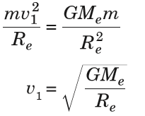
Where:
v = the value of the first cosmic velocity
Me = the mass of the Earth
Re = the radius of the Earth
G = the gravitational constant
We put the data into this formula and we obtain:
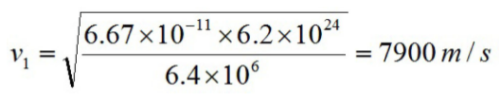
The second cosmic velocity
The second cosmic velocity is known as the escape velocity. This is the velocity that escapes from the gravitational field of a celestial body. This will be obtained by the energy conservation.
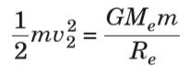
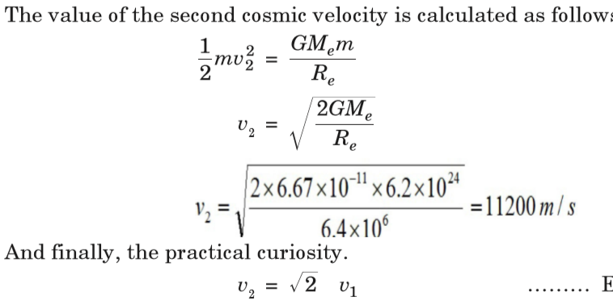
The third cosmic velocity
The third cosmic velocity is the initial velocity which a body has to have to leave the Solar System and its value is:
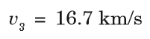
At the surface of the Earth, this velocity is about 42 km/s. But due to its revolution, it is enough to launch the body with velocity 16.7 km/s in the direction of this movement.
The fourth cosmic velocity
It is the initial velocity which a body should have to leave the Milky Way.
v₄ = 130 km/s

Learning unit 2: Examine the effects of magnetism
2.1 Describe the concepts of magnetism
2.1.1 concept of magnet
Magnetism is a class of physical phenomenon that includes forces exerted by magnets.
Magnet: a piece of material that attracts some metals by magnetism.

How does a magnet work?
The magnets have poles that are north and south. When you rub a piece of iron along a magnet, the north-seeking poles of the atoms in the iron line up in the same direction.
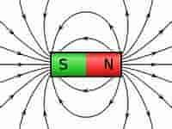

Types of Magnets
There are three types of magnets, and they are as follows:
- Permanent magnet is an object made from a material that creates its own magnetic field.
- Temporary magnet is made up soft metals that are magnetized only when exposed to a permanent magnetic field or an electric field.
- Electromagnet is made from a coil of wire that acts as a magnet when an electric current passes through it but stops when the current stops.

Magnet Shapes
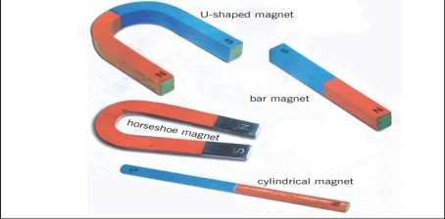

Uses of Magnet

Magnets are used in TVs, speakers, microphones, AC generators, DC generators, transformers, electric motors, burglar alarms, cassette tapes, compasses, and car speedometers.
2.1.2 Fundamental laws of magnetism
- Law of attraction
A basic law of magnetism is that unlike poles attract each other
- Law of repulsion

The like poles of magnets repeal each other

- Law of distance
The law states that the force of attraction or repulsion between two magnetic poles is directly proportional to the product of the strengths of the poles and inversely proportional to the square of the distance between them.

2.1.3 Magnetic field

A magnetic field is defined as the region around a magnet where magnetic force due to the magnets is experienced.
Symbol | B or H
Unit | Tesla
Base Unit | (Newton.Second)/Coulomb

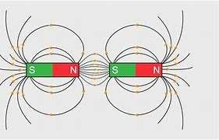
Magnetic field of magnets
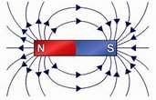

Magnetic field of the Earth

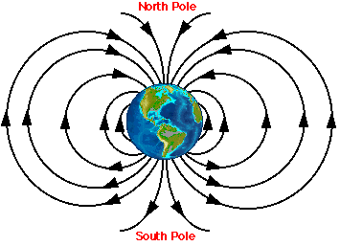
Magnetic field lines
The magnetic field is a field produced by the magnet or electric charges in motion.
Magnetic field lines can be drawn using a compass needle. The compass needle should be placed on a piece of paper near the magnet.
Magnetic field lines are a visual tool used to represent magnetic fields.

What are the Properties of Magnetic Field Lines?

- The field is tangent to the magnetic field line.
- They denote the direction of the magnetic field.
- Field lines cannot cross.
- Field strength is proportional to the line density.
- Magnetic field lines form a closed-loop.
- Field lines are continuous loops.
- Inside the magnet, the direction of the magnetic field lines is from the South Pole to the North Pole.
- Field lines have both direction and magnitude at any point on the field

Magnetic flux
Magnetic flux is defined as the number of magnetic field lines passing through a given closed surface. It provides the measurement of the total magnetic field that passes through a given surface area. Magnetic flux symbol: Φ or Φ_{B}.
Magnetic Flux Formula
Magnetic flux formula is given by:
ΦB= B.ACOS θ where, Φ_{B} is the magnetic flux, B is the magnetic field, A is the area and θ the angle at which the field lines pass through the given surface area
If a coil of n turns and area of cross section A is placed in a magnetic field of strength B, then the total flux associated with the coil is:
ΦB=nBAcosθ

Magnetic Flux Unit
Magnetic flux is usually measured with a flux meter. The SI unit of magnetic flux is Weber (Wb), The fundamental unit is Volt-seconds and the CGS unit is Maxwell.

Example: A magnetic field of 2.5 T passes perpendicular to a disc of radius 2 cm. Find the magnetic flux associated with the disc.
Solution:
Given data
B = 2.5 T,
r = 2 cm = 2 × 10^{–2} m,
θ = 0

Asked: ΦB=?

Answer

ΦB=BAcosθ=2.5×π (2×10⁻²)²×cos0=3.14×10⁻³Wb

A coil of area of cross section 10–2 m² and 100 turns is placed in a magnetic field of strength 1 T, with its axis making an angle 60° with the field. Find the total flux associated with the field.
Solution: B = 1 T, A = 10^{–2} m²,
θ=60∘, n=100
ΦB=nBAcosθ=100×1×10⁻²×cos60º=0.5Wb

MAGNETIC PERMEABILITY
Magnetic permeability also referred to as permeability in electromagnetism is a property of a magnetic material which supports the formation of a magnetic field. The term was coined by Oliver Heaviside in the year 1885. Magnetic permeability is a property that basically allows magnetic lines of force to pass through a material.

What are the different methods of magnetization?
- Stroking method. A bar of steel can be magnetized by stroking it with a bar magnet. The domains become aligned, and an N pole and an S pole are induced.
- Hammering If a steel bar is placed so that it lies in the direction of the magnetic field lines of a strong magnet and then hammered gently, the domains will begin to line up in the direction of the field.

- Electrical method. A bar of steel or iron can be magnetized by placing it in a coil of wire (solenoid). Passing a D.C (direct current) through the wire will magnetize the bar.
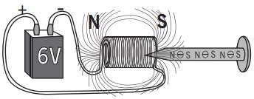

Learning outcome 2.2. Determine the magnetic field created by electric current
2.2.1 Laws of magnetic field of current-carrying conductor
Oersted’s law
In electromagnetism, Ørsted's law, also spelled Oersted's law, is the physical law stating that an electric current creates a magnetic field. ✓ Statement of Ampere’s law

Statement of Ampere’s law
Ampere’s Law can be stated as: “The magnetic field created by an electric current is proportional to the size of that electric current with a constant of proportionality equal to the permeability of free space.”
What is the Biot Savart law?

The magnetic field created by a constant electric field is described by the Biot Savart Law equation. According to this law, the magnitude, length, direction, and proximity of the electric current is related to the magnetic field.

2.2.2 Determination of magnetic field of currents

Curl right hand rule

Right hand rule states that, if the thumb of the right hand is in the direction of the current flow then, the curl fingers show the direction of the magnetic field.

The magnetic field made by a current in a straight wire curls around the wire in a ring.
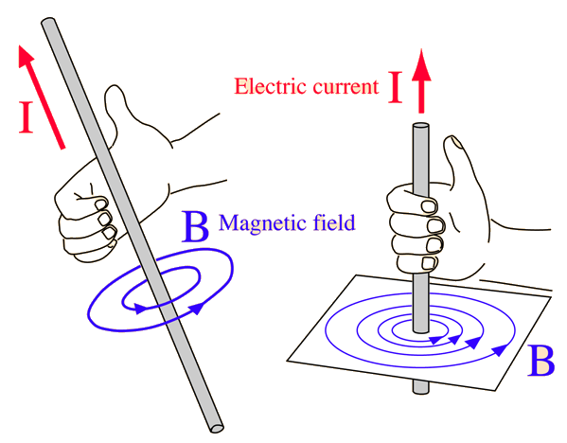

Circular coil
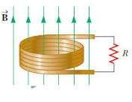
When the current flows in a circular wire (coil) the magnetic field produced has straight lines of force near the center of the coil.

C. Toroidal coil

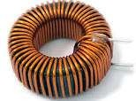
The magnetic field in the toroid are in the form of a circular loop and toroid is the sum of 5-6 circular coils joined end to end

Long Solenoid

A coil of many circular turns of insulated copper wire wrapped closely in the shape of a cylinder is called a solenoid.
In electromagnetic technology, a solenoid is an actuator assembly with a sliding ferromagnetic plunger inside the coil 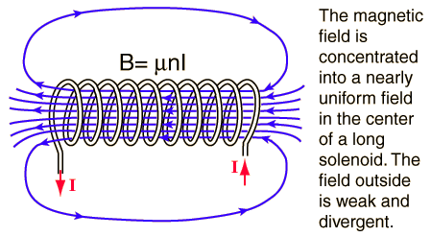

In the above expression for the magnetic field B, n = N/L is the number of turns per unit length, sometimes called the "turns density".
B=µ_{o}$\frac{NI}{l}$
µ_{o}=magnetic constant
N= number of turns
I= current
L=length of the solenoid

2.2.3 Electromagnets
An electromagnet is a type of magnet in which the magnetic field is produced by an electric current. The magnetic field disappears when the current is turned off.
Electromagnets are widely used as components of other electrical devices, such as motors, generators, relays, loudspeakers, hard disks, MRI machines, scientific instruments, and magnetic separation equipment.

2.2.4 Measuring instruments of magnetic field
1. Magnetic needle
It is a piece of magnetized steel used as an indicator on the dial of compass and in magnetic and electrical apparatus.
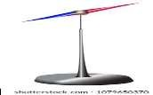
- Tesla meter
It is used when measuring the magnetization quantity of magnets and the residual magnetism of steel materials


3.Magnetometer

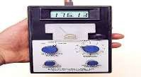
It is an instrument for measuring the strength and sometimes the direction of magnetic fields, including those on or near the earth and in space. It is also used to calibrate electromagnets and permanent magnets and to determine the magnetization of materials.

Learning outcome 2.3. Determine magnetic force
2.3.1 Lorentz force law
Lenz’s law states that the direction of the induced current is such that it opposes the change producing it.
Interpretation
The force exerted on a charged particle q moving with velocity v through an electric field E and magnetic field B. The entire electromagnetic force F on the charged particle is called Lorentz force (after the Dutch physicist Hendrick A. Lorentz) and is given by F= qE + qv*B

The strength of the magnetic components is proportional to four factors: the charge q of the particle, the speed v of the particle, the intensity B of the magnetic induction and the sine of the angle between the vectors v and B
Fleming’s left-hand rule

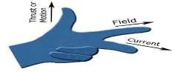
Fleming’s left-hand rule states that if we stretch the thumb, middle finger and the index finger of the left hand in such a way that they make an angle of 90 degrees and the conductor placed in the magnetic field experiences magnetic force.

    - Magnetic force on a conductor
- From Lorentz to Laplace

Lorentz force is the combination of electric and magnetic force on a point charge due to electromagnetic fields whereas, Laplace force is the magnetic force on a current- carrying wire (produced due to variation in the net value of Lorentz force).

- Magnetic force on a coil

When an electric current flows, the shape of magnetic field is very similar to the field of a bar magnetic. The field inside a solenoid is strong and uniform. The small magnetic field caused by the current in each coil add together to make a strong overall magnetic field.
The force on an individual charge moving at the drift velocity v_{d} is given by
F=q v_{d}BsinФ
- Magnetic torque on a coil
A current-carrying coil kept in a magnetic field experiences a torque, which is the cross product of the magnetic moment and the field vector. Hence the torque is maximum when the diple moment is perpendicular to the field and zero when it’s parallel or antiparallel to the field.
T=µBsinФ, Ф is the angle between B and µ

Ampere’s force two current carrying conductors

Ampere is Force between two parallel current-carrying conductors. By Fleming’s left-hand rule, this force acts towards right. Hence, two parallel wires carrying currents in the same direction attract each other and if they carry currents in the opposite direction, repel each other.
The magnetic force between two parallel, long and straight current-carrying wires equation is
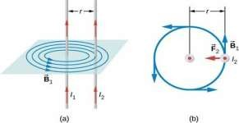
F/L = μ0 * Ia * Ib / (2πd). Here F/L is the force per unit length, d is the distance between wires, Ia and Ib are the current flowing in the first and second wires

Application of magnetic forces
- Electric motor
This simple electric motor works by the magnetic force F= IL*B. the current goes around the coil so that it points one direction in one end of the loop and in the other direction at the other end of the loop.

- Loudspeaker
In loudspeaker, current flowing in wires puts a force on a piece of magnetic material. That magnetic material moves in response. In turn, the magnet pushes a paper or plastic cone, and the cone pushes the air. The result is the sound, perhaps music.

- Moving-coil meters
It’s the basic science behind moving-coil meters. Inside a meter, a tight coil of copper

- Charge deflecting systems
A positive charge, top, moving perpendicular through a magnetic field is deflected. The right- hand rule, bottom, predicts the direction in which the positive charge will be deflected. A similar left hand rule predicts the deflection of negative charges.
N.B. They can be instruments used to measure magnetic forces.

Learning outcome 3.1. Describe the concept of waves
Wave terminologies
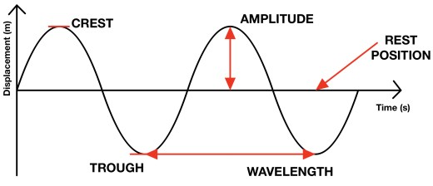
All waves are characterized by the following terms;
- Sine wave describe a smooth periodic oscillation. A sine wave is a continuous wave.
- The Time period (T) of the wave: It is the time taken between two successive wave crests or trough. It is measured in seconds (s).
- The frequency (f) is the number of complete oscillations or vibrations per second. Its SI unit is hertz (Hz). Mathematically; f = 1/T
- The wavelength (λ) is the spatial distance over which the wave makes one complete oscillation. Its SI unit is meter (m).
- The wave speed (v) is the speed at which the wave advances. Its SI unit is m/s. Speed = distance/time period travelled = λ /T or v = λ f. That is, wave speed = wavelength × frequency. This is the relationship between wavelength, frequency and velocity.
- Amplitude is defined as the maximum distance measured from equilibrium position (mean position). The amplitude is always taken as positive and is measured in meters.

Waves classifications
There are two types of waves called mechanical waves and electromagnetic waves. These waves are classified based on conditions necessary for the wave to propagate

Mechanical waves
These waves are produced by the disturbance in a material medium and they are transferred by particles of the medium.

Examples of mechanical waves: Sound waves, Water waves, Ocean waves, seismic waves.

Electromagnetic waves
These waves consist of disturbances in the form of varying electric and magnetic fields. No material medium is necessary for their movement and they travel more easily in vacuum than in matter.
In physics, electromagnetic radiation (EMR) consists of waves of the electromagnetic (EM) field, propagating through space, carrying electromagnetic radiant energy. It includes radio waves, microwaves, infrared, (visible) light, ultraviolet, X-rays, and gamma rays.

Progressive waves
A progressive wave is also called a travelling wave which consists of a disturbance moving from one point to another. As a result, energy is transferred between points. Progressive waves are classified as longitudinal and transverse waves.
Difference between Longitudinal and Transverse Waves
Transverse wave | Longitudinal wave
The movement of the particle is perpendicular to the direction of the wave. | The movement of the particle is along the direction of the wave.
It consists of troughs and crests. | It contains refractions and compressions.
Travels only in solids. | It can travel through all states of matter
Light waves are transverse waves. | sound waves are longitudinal waves.

Properties of waves
- Reflection
Reflection is the change in direction of a wavefront at an interface between two different media so that the wave front returns into the medium from which it originated. Common examples include the reflection of light, sound and water waves.

The law of reflection says that for specular reflection the angle at which the wave is incident on the surface equals the angle at which it is reflected.
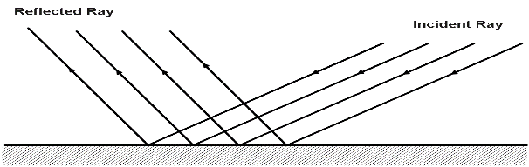

- Refraction
This is the change in the speed and direction of waves as it passes from one medium to another.
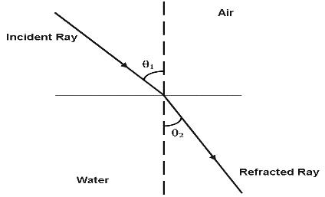

- Interference
Interference is a phenomenon in which two waves superpose to form a resultant wave of greater, lower or the same amplitude.
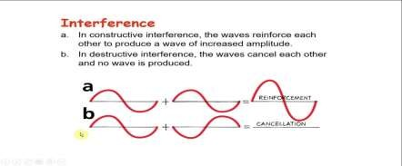
- Diffraction
Diffraction of a wave by a slit passing light through a small slit yields a diffraction pattern that depends on the size of the slit and the wavelength of the wave.
Examples: Diffraction of light (e.g., telescope,)
Diffraction of ultrasonic waves (ultrasound)
TV/radio reception
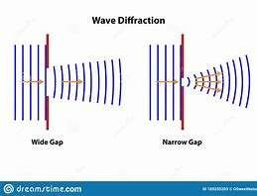
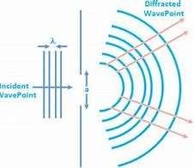
- Polarization

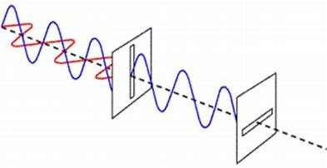
Polarization (waves) (also polarization) is a property applying to transverse waves that specifies the geometrical orientation of the oscillations.

Learning outcome 3.2. Describe the nature of sound
Origin of sound
Sound is associated with our sense of hearing and, therefore, with the physiology of our ears that intercept the sound and the psychology of our brain which interprets the sensations that reach our ears.
- Categories of a sound wave
The audibility of a sound depends on the frequency of the sound waves traveling through a medium. Sound waves within a frequency range of Hz to KHz are referred to as audible sound waves. The sound waves with a frequency less than Hz and the waves with frequency more than KHz are referred to as inaudible sound waves.

Sound pulse compression & rarefaction

When sound wave travels through a medium, say air, the particles of medium disturb in the same fashion, i.e. compression and rarefaction (depression).
When air particles come closer it is called compression. On the other hand, when particles go farther than their normal position it is called rarefaction.

Natural frequency

Natural frequency is the number of times a system will oscillate (move back and forth) between its original position and its displaced position, if there is no outside interference.

Resonance

When a light or a sound wave strikes an object that is already vibrating at some particular frequency, and if that frequency happens to match the resonant frequency of the object it’s hitting; then you’ll get what’s called resonance.

Pitch and frequency

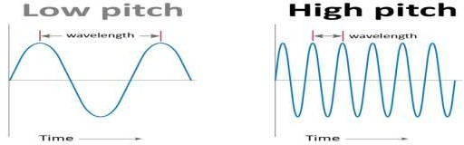
The sound of a whistle is different from the sound of a drum. The whistle makes a high sound. The drum makes a low sound. The highness or lowness of a sound is called its pitch. The higher the frequency, the higher is the pitch. Thus, frequency is the stimulus and pitch is the response.

Intensity and loudness
Loudness | Intensity
Loudness is the measure of the response of the ear to the sound | Intensity is the sound power per unit area.
Loudness is measured in decibels. | Intensity is measured in Watt per meter square.
Loudness is dependent on the sensitivity of the human ears. | Intensity is independent of the sensitivity of the human ears.
Loudness is a subjective quantity. | Intensity is objective quantity.
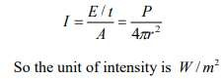

where r is the distance from the source for a spherical wave

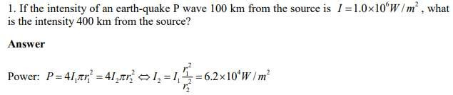

Speed of sound
The wave pattern travels with constant speed and advances a distance of one wavelength in a time interval of one period T. So the wave speed is given by
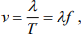
where f is the frequency of the wave.
Example
Sound waves can propagate in air. The speed of the sound depends on temperature of the air; at C 0 20 it is 344 m/s . What is the wavelength of a sound wave in air if the frequency is 262 Hz (the approximate frequency of middle C on a piano)?
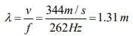

Sound waves interference

In physics, interference is a phenomenon in which two waves superpose to form a resultant wave of greater, lower, or the same amplitude.
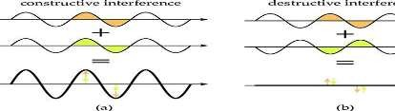
There are two types of interference: constructive and destructive. Constructive interference occurs when the wave amplitudes reinforce each other, building a wave of even greater amplitude. Destructive interference occurs when the wave amplitudes oppose each other, resulting in waves of reduced amplitude
- Interference of constructive and destructive waves in longitudinal waves

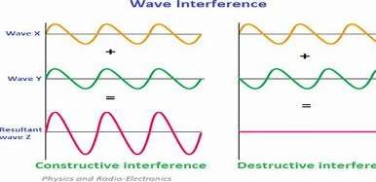
Interference in longitudinal waves occurs in sound waves.
Interference of constructive and destructive waves in transverse waves

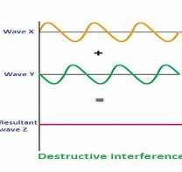
Interference in transverse mechanical waves occurs in water ripples. Interference in transverse non mechanical waves occurs in light.
- Standing waves
A vibration of a system in which some particular points remain fixed while others between them vibrate with the maximum amplitude. Compare with travelling wave.
- Doppler effect

The Doppler effect is observed whenever the source of waves is moving with respect to an observer. The Doppler effect can be described as the effect produced by a moving source of waves in which there is an apparent upward shift in frequency for observers towards whom the source is approaching...

Bow waves
A bow wave is the wave that forms at the bow of a ship when it moves through the water. Bow wave, progressive disturbance propagated through a fluid such as water or air as the result of displacement by the foremost point of an object moving through it at a speed greater than the speed of a wave moving across the water.

Shock waves
It is a strong pressure wave in an elastic medium such as air, water, or any solid material ejected from explosions or lightning, or other phenomena that create variations in pressure. It is a type of disturbance that propagates at a speed greater than the speed of sound in the medium.

Sound Instruments
Musical sound, any tone with characteristics such as controlled pitch and timbre. The sounds are produced by instruments in which the periodic vibrations can be controlled by the performer.

Turning fork
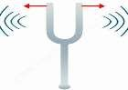
A tuning fork is an acoustic resonator in the form of a two-pronged fork with the prongs (tines) formed from a U-shaped bar of elastic metal (usually steel).

- Radio broadcasts

Radio broadcasting is transmission of audio (sound), sometimes with related metadata, by radio waves intended to reach a wide audience.
What are the different types of radio-wave broadcasting?
Extensions of traditional radio-wave broadcasting for audio broadcasting in general include cable radio, local wire television networks, DTV radio, satellite radio, and internet radio via streaming media on the Internet.

Noise and Music

Music is what pleases our sense of hearing. It depends on numerous factors and varies from person to person. On the other hand, the definition of noise is hazy, it’s not clear. The boundaries that separate musical sound from noise is blurry.

Anti-noise technology

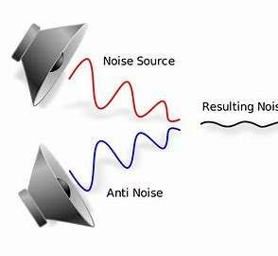
The concept of Active Noise Control, or 'Anti-Noise' involves taking a sound wave and producing an exact mirror image. By adding these two sound waves together they "cancel" each other out and the resulting pressure is zero so the waves hitting the ear drum at the same time would not produce any sound.

Musical instruments

A musical instrument is a device created or adapted to make musical sounds. In principle, any object that produces sound can be considered a musical instrument—it is through purpose that the object becomes a musical instrument. A person who plays a musical instrument is known as an instrumentalist.

Learning outcome 3.3. Describe the Nature of Light

3.3.1 Electromagnetic waves

Electromagnetic waves are formed when an electric field comes in contact with a magnetic field. There are seven types of electromagnetic waves: radio waves, microwaves, infrared light, visible light, ultraviolet light, X-rays, and gamma rays.

Electromagnetic spectrum

The electromagnetic spectrum is a continuous range of wavelengths. The entire range (electromagnetic spectrum) is given by radio waves, microwaves, infrared radiation, visible light, ultra-violet radiation, X-rays, gamma rays and cosmic rays in the increasing order of frequency and decreasing order of wavelength
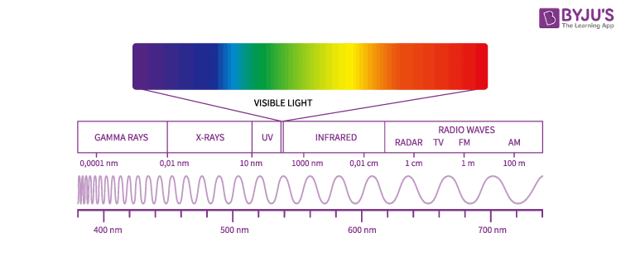

Electromagnetic velocity

The velocity of electromagnetic radiation is 3x108 m/s.
Properties of electromagnetic waves

Reflection
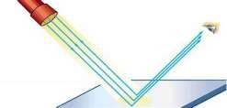
When a ray of light approaches a smooth polished surface and the light ray bounces back, it is called the reflection of light.

Refraction
A light ray refracts whenever it travels at an angle into a medium of different refractive index.
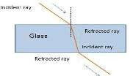

Interference
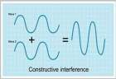
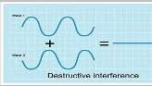
Interference of Light Waves is defined as the modification in the distribution of light energy when two or more waves superimpose each other.

Diffraction
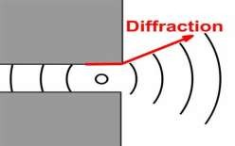
Diffraction is normally taken to refer to various phenomena which occur when a wave encounters an obstacle. It is described as the apparent bending of waves around small obstacles and the spreading out of waves past small openings.

Polarization
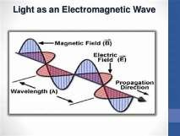
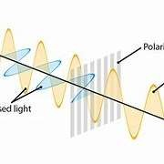
The phenomenon of restriction of the vibrations of light waves in a particular plane perpendicular to the direction of propagation of wave motion is called polarization.

Nature of color
Color is used to differentiate between colors that have been manufactured or created by humans that are rare or nonexistent in nature. This can include chemical pigments and colors created for digital technologies that have no natural analogue.

Dispersion and prisms

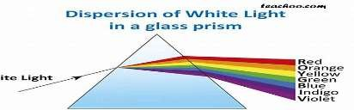
The prism splits the white light into seven different colors. This splitting of white light into many colors is called as a dispersion of light.

Selective reflection
It is the reflection emitted by a surface that reflects waves of different lengths with varying intensity.

Selective transmission
Selective transmission is when selected color wavelengths are allowed to pass through the material. Example: Colored glass.
3.3.2 color theory

What is Color Theory?

Color theory is a multitude of categories, definitions and concepts.

The Color of Light

Sir Isaac Newton developed the theory that all colors are mixtures of red, green, and blue light. This resulted in the first known color circle in 1666.

The Color of Paint

In 1766 the scientist Moses Harris created the first color wheel to classify Red, Yellow, and Blue as the primary colors.

Moses Harris worked with paint (Newton worked with light) following a theory (by a French painter) that all colors are mixtures of red, yellow, and blue pigments.

Primary colors are the main colors in a given color system.

Primary colors cannot be produced by mixing other colors a color system.
- The primary colors for light are Red, Green and Blue
- The primary colors for print are Cyan, Magenta and Yellow
- The primary colors for paint are Red, Yellow and Blue

3.3.3 Light emission

Modern theory explains the emission of light by matter in terms of electronic energy levels. An electron of relatively high energy may jump to a condition of lower energy, giving off the energy difference as electromagnetic radiation.

Atomic excitation
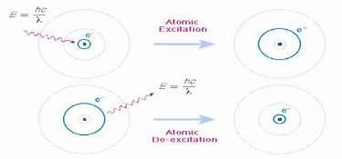
In atoms, the excitation energy is absorbed by the orbiting electrons that are raised to higher distinct energy levels. In atomic nuclei, the energy is absorbed by protons and neutrons that are transferred to excited states.

Emission and absorption spectra

The main difference between emission and absorption spectra is that an emission spectrum has different colored lines in the spectrum, whereas an absorption spectrum has dark- colored lines in the spectrum.

Phosphorescence

Luminescence that is caused by the absorption of radiations (such as light or electrons) and continues for a noticeable time after these radiations have stopped — compare fluorescence.

Lamps

Lamp. A filament lamp is a common type of light bulb. It contains a thin coil of wire called the filament. This heats up when an electric current passes through it, and produces light as a result. The resistance of a lamp increases as the temperature of its filament increases.

Lasers

LASER is an abbreviation of Light Amplification by Stimulated Emission of Radiation. Lasers are light beams so powerful that they can travel miles into the sky, and they can also cut through the surfaces of metals. Theodore H Maiman at Hughes Research Laboratories was the first person to build a practical laser in 1960.
List of Laser Types
Lasers are classified into 6 types based on the types of medium used in them, and they are:
- Solid-state lasers
- Gas lasers
- Liquid lasers
- Semiconductor lasers
- Chemical lasers
- Metal-vapor lasers

Learning Unit 4: APPLY THE CONCEPT OF ELECTROMAGNETIC FIELD

Learning outcome 4.1. Classify magnetic materials

Content 1: Magnetization
- The process of making a substance temporarily or permanently magnetic, as by insertion in a magnetic field.
- The extent to which an object is magnetized.
- The property of being magnetic.
The magnetization process
A permanent magnet is magnetized by application of a strong outer magnetic field.

Magnetic field
Magnetic field is a vector field that describes interaction between moving electric charges (that is, electric currents), and magnetic materials.

Magnetic susceptibility
Magnetic susceptibility is a dimensionless proportionality constant that indicates the degree of magnetization of a material in response to an applied magnetic field.
Magnetic Flux Leakage (MFL)

Magnetic flux leakage (MFL) is a magnetic method of non-destructive testing that is used to detect corrosion, pitting and wall loss in steel structures.
magnetic dipole moment
Magnetic moment, also known as magnetic dipole moment, is the measure of the object’s
tendency to align with a magnetic field.

“Magnetic Moment is defined as magnetic strength and orientation of a magnet or other
object that produces a magnetic field.”

The magnetic moment is a vector quantity. The objects have a tendency to place themselves in such a way that the magnetic moment vector becomes parallel to the magnetic field lines. The direction of the magnetic moment points from the south to the north pole of a magnet. The magnetic field created by a magnet is directly proportional to the magnetic moment.
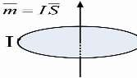
Magnetic domain
A magnetic domain is a region within a magnetic material in which the magnetization is in a uniform direction. This means that the individual magnetic moments of the atoms are aligned with one another and they point in the same direction.
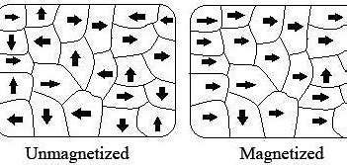

Content 2: Magnetic Hysteresis Loop

The hysteresis loop shows the relationship between the magnetic flux density and the magnetizing field strength.
Magnetic hysteresis occurs when an external magnetic field is applied to a ferromagnet such as iron and the atomic dipoles align themselves with it. Even when the field is removed, part of the alignment will be retained: the material has become magnetized. Once magnetized, the magnet will stay magnetized indefinitely. To demagnetize it requires heat or a magnetic field in the opposite direction.
This is the effect that provides the element of memory in a hard disk drive.

Coercivity
Movement on the loops is counter clockwise. Coercivity, also called the magnetic coercivity, coercive field or coercive force is a measure of the ability of a ferromagnetic material to withstand an external magnetic field without becoming demagnetized.
Coercivity is usually measured in oersted or ampere /meter units and is denoted HC.

Magnetic retentivity: The ability to retain the generated magnetization in a magnetic material when the magnetizing force is removed

Retentivity is a determination of the residual flux density corresponding to the saturation induction of a magnetic material.
Saturation magnetization is the maximum possible magnetization of ferromagnetic material, characterized by parallel orientation of all magnetic moments inside the material

Content 3: Classification of magnetic materials
- Ferromagnetic materials

Ferromagnetic materials are a certain group of substances that tend to manifest or display strong magnetism in the direction of the field due to the application of a magnetic field. Common examples of ferromagnetic substances are Iron, Cobalt, Nickel, etc.
- Paramagnetic materials

Paramagnetic materials are metals that are weakly attracted to magnets. These materials incorporate aluminum, gold, oxygen etc. The atoms of these substances comprise electrons most of which spin in the same direction.

- Diamagnetic materials

Diamagnetic materials are those that some people generally think of as non-magnetic, and include water, wood, most organic compounds such as petroleum and some plastics, and many metals including copper, particularly the heavy ones with many core electrons, such as mercury, gold and bismuth. Diamagnetic materials do not have atomic dipoles because the resulting magnetic moment of each atom is zero owing to paired electrons.

- Ferrimagnetic materials

A ferrimagnetic material is a material that has populations of atoms with opposing magnetic moments, as in antiferromagnetism. Examples include hematite, metals such as chromium, alloys such as iron manganese (FeMn), and oxides such as nickel oxide (NiO)

Learning outcome 4.2. Determine the induced emf in a circuit

Content 1: Concept of electromagnetic induction (EMI)

What is Electromagnetic Induction?
Electromagnetic Induction was discovered by Michael Faraday in 1831 and James Clerk
Maxwell mathematically described it as Faraday’s law of induction.

Electromagnetic Induction is a current produced because of voltage production (electromotive force) due to a changing magnetic field.
This either happens when a conductor is placed in a moving magnetic field (when using AC power source) or when a conductor is constantly moving in a stationary magnetic field.
FARADAY’S LAW

Definition of terms

Magnetic flux (Φ): is a measure of the quantity of magnetism, being the total number of magnetic lines of force passing through a specified area in a magnetic field. It represents the strength of the magnetic field over a given area. The SI unit is weber (symbol Wb).
Magnetic flux density (B) is the amount of magnetic flux through a unit area taken perpendicular to the direction of the magnetic flux, it is a vector quantity. Its SI unit is tesla (symbol T), or N/(A·m) expressed in SI base unit.
The law states that; the electromotive force induced in a conductor is directly proportional to the rate at of change of the magnetic flux linked to the conductor
ε 𝖺 – ΔΦ/Δt ⇒ ε = – ΔΦ/Δt (since the constant k = 1)

In case the conductor has N turns, ε = – NΔΦ/Δt
Example1: A small piece of metal wire is dragged across the gap between the pole pieces of a magnet in0.5 second. The magnetic flux between the pole pieces is known to be 8 × 10-4 Wb. Calculate the emf induced in the wire.
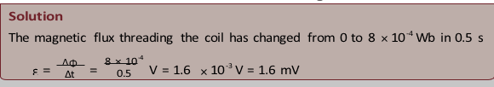

Example2
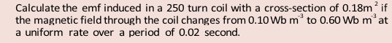
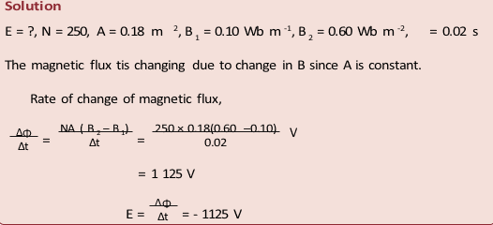
LENS’S LAW

Lenz’s law, in electromagnetism, statement that an induced electric current flows in a direction such that the current opposes the change that induced it. This law was deduced in 1834 by the Russian physicist Heinrich Friedrich Emil Lenz (1804–65).
FLEMING’S RIGHT-HAND RULE
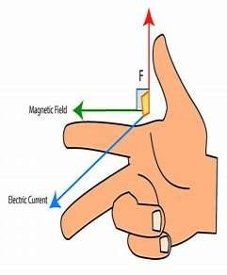
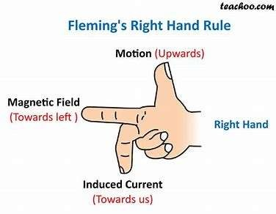

Fleming’s Right Hand Rule states that if we arrange our thumb, forefinger and middle finger of the right-hand perpendicular to each other, then the thumb points towards the direction of the motion of conductor relative to the magnetic field, the forefinger points towards the direction of the magnetic field and the middle finger points towards the direction of the induced current.

Content 2: Induced emf and induced current
Whenever there is a change in the magnetic flux linked with a closed circuit an emf is produced. This emf is known as the induced emf and the current that flows in the closed circuit is called induced current.
Self-Induction

An electrical phenomenon whereby an electromotive force (EMF) is generated in a closed circuit by a change in the flow of current
Self-Inductance

Self-inductance, usually just called inductance, is the ratio between the induced voltage and the rate of change of the current. Thus, inductance is a property of a conductor or circuit, due to its magnetic field, which tends to oppose changes in current through the circuit.
Symbols: L Derivations from other quantities: L = V / ( I / t ), L = Φ / I

In SI base units: kg⋅m²⋅s−2⋅A−2 SI unit: henry (H)

Mutual Inductance is the basic operating principle of the transformer, motors, generators, and any other electrical component that interacts with another magnetic field. Then we can define mutual induction as the current flowing in one coil that induces a voltage in an adjacent coil.
What is motional EMF?

This induced emf due to the motion of an electric conductor in the presence of the magnetic field is called motional emf.
Thus, emf can be induced in two major ways:
- Due to the motion of a conductor in the presence of a magnetic field.
- Due to the change in the magnetic flux enclosed by the circuit.

Content 3: Applications of EMI
- Transformers

A transformer operates on the principals of “electromagnetic induction”, in the form of Mutual
Induction.

Mutual induction is the process by which a coil of wire magnetically induces a voltage into another coil located in close proximity to it.
Transformers are capable of drastically changing voltages. Transformers that increase voltage are called “step-up transformers” while those that decrease voltage are “step-down transformers.”
- Generators

A generator is based on the principle of electromagnetic induction. This phenomenon was discovered by Michael Faraday and it states that a current is produced in a conductor when it is moved through a magnetic field. of how the flux, coil and current interact in order to produce current and electromotive force.

- Induction motors

Whenever a conductor is placed in a varying magnetic field, EMF induces and this emf is called an induced emf and if the conductor is a closed circuit than the induced current flows through it.

Learning outcome 4.3. Apply the equation of propagation of electromagnetic

Content 1: Properties of electromagnetic waves

Electromagnetic waves or EM waves are waves that are created as a result of vibrations between an electric field and a magnetic field. In other words, EM waves are composed of oscillating magnetic and electric fields.
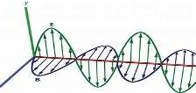

What is the speed of electromagnetic waves in free space?

The speed of any electromagnetic waves in free space is the speed of light c = 3*108 m/s.
Electromagnetic waves can have any wavelength λ or frequency f as long as λf = c.

EM waves wavelength

Electromagnetic waves form a spectrum of different wavelengths. This spectrum includes visible light, X-rays and radio waves.
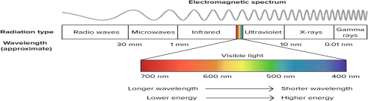

EM waves frequency

The electromagnetic spectrum (EMS) is the general name given to the known range of electromagnetic radiation. Wavelengths increase from approximately 10 -18 m to 100 km, and this corresponds to frequencies decreasing from 3 × 10 26 Hz to 3 ×10 3 Hz.
Amplitude
the maximum extent of a vibration or oscillation
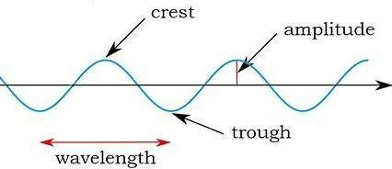

Content 2: EM Wave Equation

All waves are characterized by the following terms;

The Time period (T) of the wave is the time it takes for one wavelength of the wave to pass a point in space or the time for one cycle to occur.
It is also defined as the time taken between two successive wave crests or trough. It is measured in seconds (s).
The frequency (f) is the number of wavelengths that pass a point in space per second. In another words, it can be defined as the number of complete oscillations or vibrations per second. Its SI unit is hertz (Hz). Mathematically;
f=1/T
The wavelength (ɻ) is the horizontal distance in space between two nearest points that are oscillating in phase (in step) or the spatial distance over which the wave makes one complete oscillation. Its SI unit is meter (m).
The wave speed (v) is the speed at which the wave advances. Its SI unit is m/s.

Speed = distance travelled/time period

Or v = ɻ f
That is, wave speed = wavelength × frequency.

This is the relationship between wavelength, frequency and velocity.

Amplitude is defined as the maximum distance measured from equilibrium position (mean position). The amplitude is always taken as positive and is measured in metres.
Phase difference (phase angle) is the angular difference between two points on the wave or between two waves.
Phase difference is a whole number and is calculated using simple proportions;

Ф=2πx/ ɻ

The wave number, also called the propagation number k, is the spatial frequency of a wave, either in cycles per unit distance or radians per unit distance.
k= Ф/x=2π/ ɻ

The Intensity (I) of a wave or the power radiated by a source are proportional to the square of the amplitude (x).
I 𝖺 x2

Equation of a wave

y= A sin (wt – Ф), Y is the displacement

Electric field equation

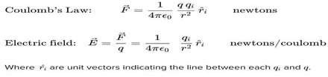

Magnetic field equation
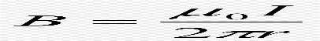

Content 3: Mechanism of propagation of electromagnetic waves

The Production of EM waves

A charged particle produces an electric field. This electric field exerts a force on other charged particles. Positive charges accelerate in the direction of the field and negative charges accelerate in a direction opposite to the direction of the field.

A moving charged particle produces a magnetic field. This magnetic field exerts a force on other moving charges. The force on these charges is always perpendicular to the direction of their velocity and therefore only changes the direction of the velocity, not the speed.

An accelerating charged particle produces an electromagnetic (EM) wave. Electromagnetic waves are electric and magnetic fields traveling through empty space with the speed of light

Direction of propagation

E is the electric field vector, and B is the magnetic field vector of the EM wave. For electromagnetic waves E and B are always perpendicular to each other and perpendicular to the direction of propagation. The direction of propagation is the direction of E x B.

EM WAVE ENERGY
Electromagnetic waves are emitted by electrically charged particles undergoing acceleration, and these waves can subsequently interact with other charged particles, exerting force on them. EM waves carry energy, momentum and angular momentum away from their source particle and can impart those quantities to matter with which they interact.

What is energy loss in electromagnetic waves?

In the case of electromagnetic waves like light, each individual photon inside the light has an energy that is decided by the frequency. When waves move, their energy spreads out. This spreading out can cause energy to be absorbed by the general environment in ways that might not be desirable. We call this energy loss

Activity
A travelling wave is described by the equation y(x, t) = 0.003 cos (20x +200t) where y and x are measured in meters and t in seconds. What is the direction in which the wave is travelling? Calculate the following physical quantities:
- Angular wave number

- Wavelength

- Angular frequency

- Frequency

- Time period

- Wave speed

- Amplitude

- Particle velocity when x = 0.3 m and t = 0.02 s

- Particle acceleration when x = 0.3 m and t = 0.02 s

Learning outcome 4.4. Categorize Mobile phone and radio communication

Content 1: Interpretation of concepts in transmission

Transmission system
In telecommunications, a transmission system is a system that transmits a signal from one place to another. The signal can be an electrical, optical or radio signal.

Terms used in transmission system:

In electronics and telecommunications, a transmitter or radio transmitter is an electronic device which produces radio waves with an antenna. The transmitter itself generates a radio frequency alternating current, which is applied to the antenna. When excited by this alternating current...
Channel in electronics is the medium of passing information from one device to other.
communication channel can be divided in two part.
wired: this type of channel uses cables to connect devises.
Receiver, in electronics, any of various devices that accept signals, such as radio waves, and convert them (frequently with amplification) into a useful form.
Examples are telephone receivers, which transform electrical impulses into audio signals, and radio or television receivers, which accept electromagnetic waves and convert them into sound or television pictures.

Digital communication is the process of devices communicating information digitally.

Digital communication: Digital communication system exchange (both transmit and receive) information to /from digital sources. A digital (information) source produces a finite set of possible messages. Typewriter is a good example of a digital source. There is a finite no. of characters that can be emitted by this source.

Analog communication is the process of conveying (sending, receiving, and processing) of information including image, voice, and video by using continuous signals or analog signals.
Analog communication: Analog communication system exchange (both transmit and receive) information to /from analog sources. A microphone is a good example of an analog source. An analog information source produces messages that are defined on a continuum.
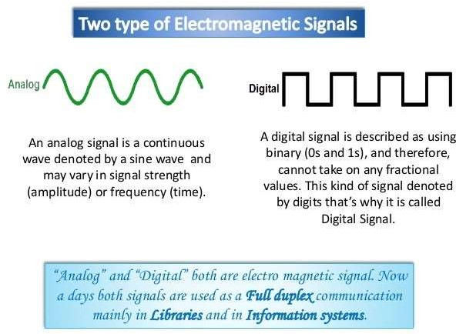

Content 2: Description principle of cellular radio and Structure of cellular network.

Principle of cellular radio

The cellular concept is a major breakthrough in solving the problem of spectral congestion and user capacity. It involves dividing the area into small parts called cells. The neighboring base stations are assigned different groups of channels so that the interference between base stations (and the mobile users under their control) is minimized. It offers very high capacity in a limited spectrum allocation without any major technological changes.

Structure of cellular network
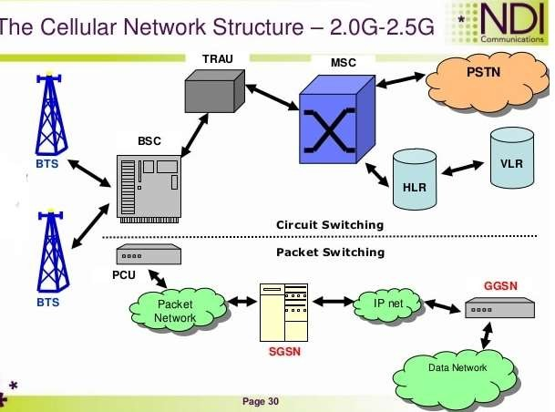
Cellular network technology supports a hierarchical structure formed by the base transceiver station (BTS), mobile switching center (MSC), location registers and public switched telephone network (PSTN). The BTS enables cellular devices to make direct communication with mobile phones.

Content 3: Identification of types of modulations (AM, FM, and PM).

In electronics and telecommunications, modulation is the process of varying one or more properties of a periodic waveform, called the carrier signal, with a separate signal called the modulation signal that typically contains information to be transmitted.
For example, the modulation signal might be an audio signal representing sound from a microphone, a video signal representing moving images from a video camera, or a digital signal representing a sequence of binary digits, a bitstream from a computer.
Types of modulation:
There are a few general types of modulation; Frequency Modulation (FM), Phase Modulation (PM) and Amplitude modulation (AM).

- Frequency modulation (FM)
This is a kind of modulation which is used in every high broadcasts. The frequency of the carrier is altered at a rate equal to the frequency of the audio frequency but the amplitude remains constant.
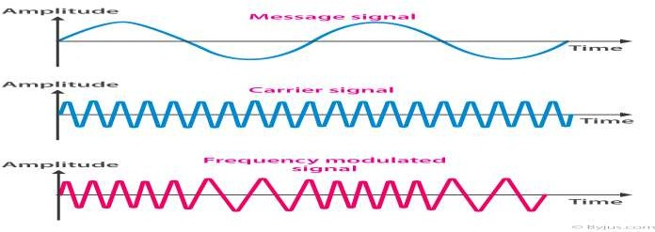

- Amplitude modulation (AM)
In amplitude modulation, the information signal is used to vary the amplitude of the carrier so that it follows the wave shape of information signal. Here, before the information is transmitted, it is first mixed to a carrier signal so that it can be transmitted over a long distance with low attenuation.
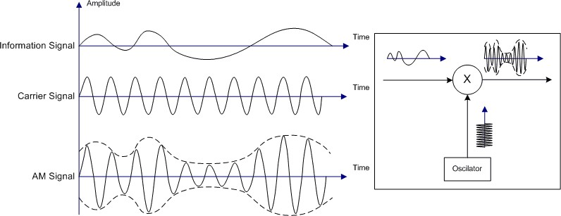
The modulated signal contains other frequencies called side frequencies which are created on either side of the carrier. If the carrier frequency is f_{c} and modulated frequency is f_{m}, two new frequencies are f_{c}– f_{m} and f_{c}+f_{m}.
- Phase modulation (PM)
Phase modulation is a form of modulation that encodes information as variations in the instantaneous phase of the carrier wave. It is widely used for transmitting radio waves and is an integral part of many digital transmission coding schemes that underlie a wide range of technologies like WiFi, GSM and satellite television. In this type of modulation, the amplitude and frequency of the carrier signal remains unchanged after PM. The modulating signal is mapped to the carrier signal in the form of variations in the instantaneous phase of the carrier signal.
Phase modulation is closely related to frequency modulation and is often used as intermediate step to achieve FM.
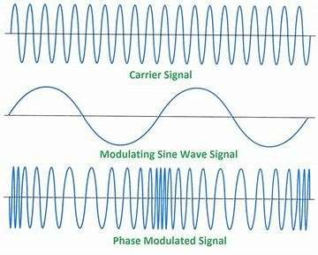

Content 4: Description of Post, telegraph and telephone (PTT)
A postal, telegraph and telephone service (or PTT) is a government agency responsible for postal mail, telegraph and telephone services. Such monopolies existed in many countries, though not in North America or Japan.
Many PTTs have been partially or completely privatized in recent years. In some of those privatizations, the PTT was renamed completely, whereas in others, the name of the privatized corporation has been only slightly modified.
Postal services transport mail and small packages to destinations around the world, and they are mostly public corporations.
A telegraph is a communication system in which information is transmitted over a wire through a series of electrical current pulses, usually in the form of Morse code. The basic components include a source of direct current, a length of wire or cable, and a current-indicating device such as a relay, buzzer or light bulb.
Telephony is the technology associated with the electronic transmission of voice, fax, or other information between distant parties using systems historically associated with the telephone, a handheld device containing both a speaker or transmitter and a receiver. With the arrival of computers and the transmission of digital information over telephone systems and the use of radio to transmit telephone signals, the distinction between telephony and telecommunication has become difficult.

Learning Unit 5: DESCRIBE SEMICONDUCTING MATERIALS
Learning outcome 5.1. Describe the fundamental properties of semiconductor materials

An electrical conductor is defined as materials that allow electricity to flow through them easily. This property of conductors that allow them to conduct electricity is known as conductivity. The flow of electrons in a conductor is known as the electric current. While materials that do not allow electricity to pass through are insulators.
Some examples of conductors of electricity are. Copper. Aluminium. Silver. Gold. Graphite. Platinum. Water.
Examples of non - conductor... Sulphur. Phosphorus. Wood.

Semiconductor, any of a class of crystalline solids intermediate in electrical conductivity between a conductor and an insulator. Semiconductors are employed in the manufacture of various kinds of electronic devices, including diodes, transistors, and integrated circuits.
Examples of Semiconductors: Gallium arsenide, germanium, and silicon are some of the most commonly used semiconductors. Silicon is used in electronic circuit fabrication and gallium arsenide is used in solar cells, laser diodes, etc.

Content 2: Basics of semiconductors
VALENCE ELECTRON
Valence electrons, in simple words, are the electrons revolving continuously in the outermost shell or orbit of an atom.
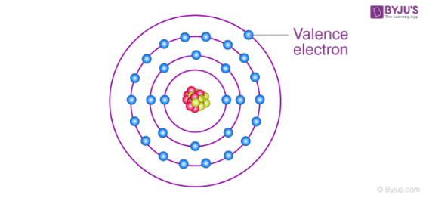

FREE ELECTRONS
The electrons which are not attached to the nucleus of an atom and free to move when external energy is applied are called free electrons.
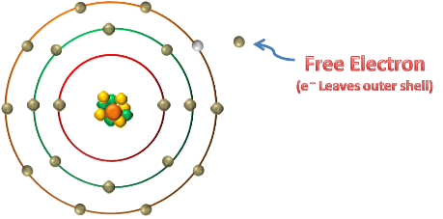

HOLES
What is an electron hole?

Electron hole. If an electron is excited into a higher state, it leaves a hole in its old state. In physics, chemistry, and electronic engineering, an electron hole (often simply called a hole) is the lack of an electron at a position where one could exist in an atom or atomic lattice.
In solid-state physics, the electron mobility characterizes how quickly an electron can move through a metal or semiconductor when pulled by an electric field. There is an analogous quantity for holes, called hole mobility. The term carrier mobility refers in general to both electron and hole mobility.

Content 3: Current in semiconductors

How is current produced in a semiconductor?

In a semiconductor, current is produced in two different ways. There is the electron current and the hole current. The electron current is produced when electrons are pushed from the negative terminal into the semiconductor.
Intrinsic semiconductors

Intrinsic semiconductors are those semiconductors that are always in extremely pure form. It is also known as an undoped semiconductor.
The best examples of intrinsic semiconductors are crystals of Pure Silicon and Pure Germanium.

Extrinsic semiconductors
Extrinsic semiconductors are semiconductors that are doped with specific impurities. The impurity modifies the electrical properties of the semiconductor and makes it more suitable for electronic devices such as diodes and transistors.
Examples Boron, Aluminium,Gallium, etc.
What is pn junction insemiconductor?
A p-n junction is an interface or a boundary between two semiconductor material types, namely the p-type and the n-type, inside a semiconductor. The p-side or the positive side of the semiconductor has an excess of holes and the n-side or the negative side has an excess of electrons.

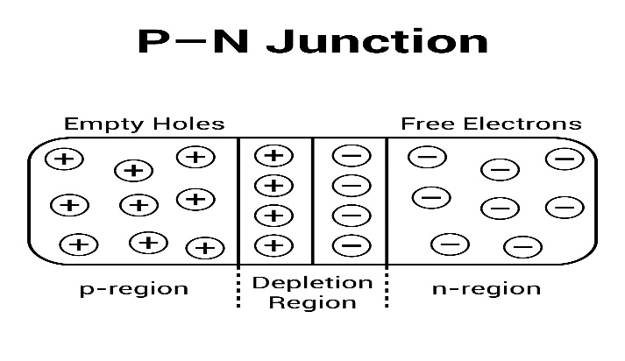

Learning outcome 5.2. Describe the principles of semiconductor devices

Content 1: N-type and P-type materials

An N-type semiconductor is an impurity mixed semiconductor material used in electronics.
The pentavalent impure atoms like phosphorus, arsenic, antimony, bismuth or some other chemical element are used to produce n-type semiconductors.
A p-type semiconductor material is formed by the addition of group III elements or we can
say trivalent impurity to a pure (intrinsic) semiconductor.
A P-N junction is an interface or a boundary between two semiconductor material types, namely the p-type and the n-type, inside a semiconductor.

Content 2: Diode
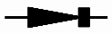
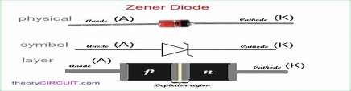
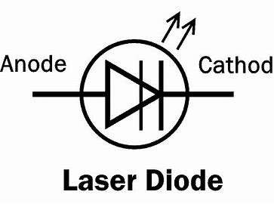

A diode is a semiconductor device that essentially acts as a one-way switch for current. It allows current to flow easily in one direction, but severely restricts current from flowing in the opposite direction.

Diodes are also known as rectifiers because they change alternating current (ac) into pulsating direct current (dc). Diodes are rated according to their type, voltage, and current capacity.
- Examples of diodes

- Zener diode

What are the applications of Zener diode?

Following are the applications of Zener diode: Zener diode is used as a Shunt voltage regulator for regulating voltage across small loads. The breakdown voltage of Zener diodes will be constant for a wide range of current.

- Laser diode

What is a laser diode?
A laser diode is an optoelectronic device, which converts electrical energy into light energy to produce high-intensity coherent light. In a laser diode, the p-n junction of the semiconductor diode acts as the laser medium or active medium.
- Light emitting-diode

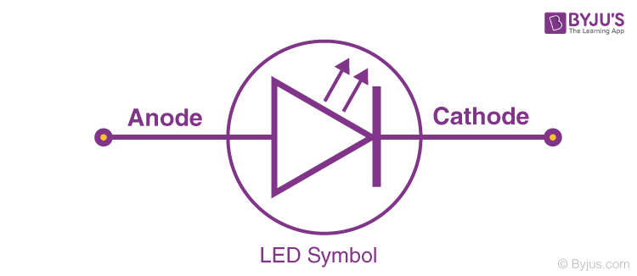
What is light emitting diode (LED)?

Light Emitting Diode is an electric component that emits light when the electric current flows through it. It is a light source based on semiconductors. When current passes through the LED, the electrons recombine with holes emitting light in the process.
- Photodiode

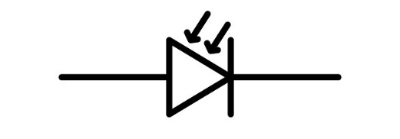
A photodiode is a PN-junction diode that consumes light energy to produce an electric current. They are also called a photo-detector, a light detector, and a photo-sensor. Photodiodes are designed to work in reverse bias condition. Typical photodiode materials are Silicon, Germanium and Indium gallium arsenide.

tunnel diode
A tunnel diode or Esaki diode is a type of semiconductor diode that has effectively "negative resistance" due to the quantum mechanical effect called tunneling.
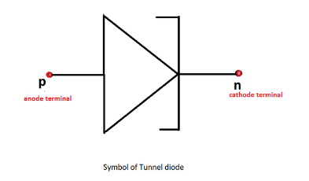

  - Junction diode as rectifier

Junction Diode as a Rectifier Rectification is the process of conversion of alternating current or alternating voltage into a direct current or direct voltage. The device which is used for this conversion process is known as a
rectifier.
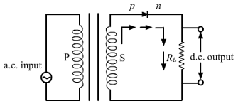
- Full wave rectifier

A full wave rectifier can be defined as a type of rectifier that converts both halves of each cycle of an alternating current (AC signal) into pulsating DC signal. In other words, full wave rectifiers are used to convert AC voltage to DC voltage and require multiple diodes to construct.
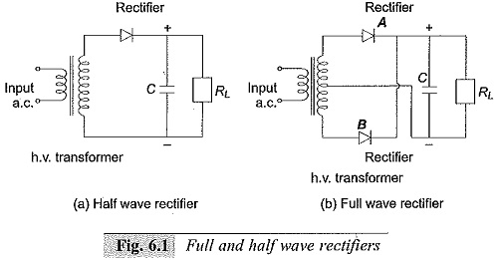
- A bridge circuit

A bridge circuit is a topology of electrical circuitry in which two circuit branches (usually in parallel with each other) are "bridged" by a third branch connected between the first two branches at some intermediate point along them.
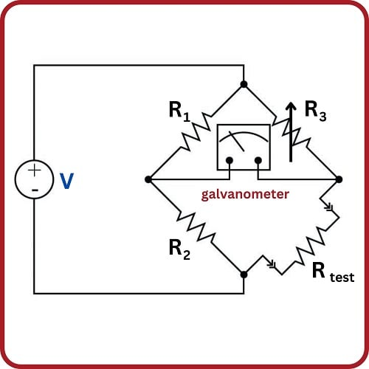

Content 3: Transistor
It is composed of semiconductor material, usually with at least three terminals for connection to an electronic circuit. A voltage or current applied to one pair of the transistor's terminals controls the current through another pair of terminals.

Examples of transistor

- Bipolar transistor
A bipolar transistor allows a small current injected at one of its terminals to control a much larger current flowing between two other terminals, making the device capable of amplification or switching.

- unijunction transistor (UJT)
A unijunction transistor (UJT) is a three-lead electronic semiconductor device with only one junction that acts exclusively as an electrically controlled switch. The UJT is not used as a linear amplifier.
3. Field-effect transistor
The field-effect transistor (FET) is a type of transistor that uses an electric field to control the flow of current in a semiconductor. FETs are devices with three terminals: source, gate, and drain. FETs control the flow of current by the application of a voltage to the gate, which in turn alters the conductivity between the drain and source.

Current flow in a transistor

We know that in transistors and diodes, electric current is carried by both free electrons and holes. Free electrons and holes travel in opposite directions. For example, if free electrons flow from left to right, then the holes will flow from right to left.

However, the direction of holes is assumed as same as the direction of the current.

Conventional current direction in pnp transistor

Consider the pnp transistor as shown in the below figure. The emitter-base junction (p-n junction) or emitter junction is forward biased and the base-collector junction (n-p junction) or collector junction is reverse biased.

Common-Emitter (C-E) characteristic

In common emitter configuration, the emitter terminal is grounded so the common emitter configuration is also known as grounded emitter configuration. Sometimes common emitter configuration is also referred to as CE configuration, common emitter amplifier, or CE amplifier. The common emitter (CE) configuration is the most widely used transistor configuration.

Current amplifier in C-E mode

Current gain

The current gain of a transistor in CE configuration is defined as the ratio of output current or collector current (IC) to the input current or base current (IB). The current gain of a transistor in CE configuration is high.

Voltage amplification

The Voltage Amplification (Av) or Gain of a voltage amplifier is a ratio of how much bigger is the output than the input, and so has no units. It is a basic measure of the Gain or effectiveness of the amplifier.

- Power gain is similar to voltage gain; it is the ratio of output power to input power

Learning outcome 5.3. Describe the principles of operational amplifiers

Content 1: Introduction on integrated circuit

An integrated circuit is a complex layering of semiconductors, coppers, and other interconnected materials to form resistors, transistors and other components. The cut and formed combinations of these wafers are known as a die. The semiconductor wafers that make up the ICs are fragile, and the connections between the layers very intricate.
What are the different types of IC integrated circuits?

Based on planned use, an IC integrated circuit can be classified as a digital integrated circuit, mixed integrated circuit and analogue integrated circuit.
What are digital integrated circuits?
The Digital Integrated circuits are specially designed using several digital logic flip flops, multiplexers, gates and other electrical elements of circuits. The logic gates operate with digital input and binary input data like 0 and 1.

Analog Integrated Circuits
The integrated circuits that operate over a continuous range of signals are called Analog ICs. These are subdivided into linear Integrated Circuits (Linear ICs) and Radio Frequency Integrated Circuits (RF ICs). In fact, the relationship between the voltage and current may be nonlinear in some cases over a long range of the continuous analog signal.

Mixed Integrated Circuits

The integrated circuits that are obtained by the combination of analog and digital ICs on a single chip are called Mixed ICs. These ICs functions as Digital to Analog converters, Analog to Digital converters (D/A and A/D converters), and clock/timing ICs. The circuit depicted in the above figure is an example of the mixed integrated circuit which is a photograph of the 8 to 18 GHz self-healing radar receiver.

Content 2: The operational amplifier
An Operational Amplifier, or op-amp for short, is fundamentally a voltage amplifying device designed to be used with external feedback components such as resistors and capacitors between its output and input terminals. These feedback components determine the resulting function or “operation” of the amplifier and by virtue of the different feedback configurations whether resistive, capacitive or both, the amplifier can perform a variety of different operations, giving rise to its name of “Operational Amplifier”.

The operational amplifier as amplifier

An operational amplifier is an integrated circuit that can amplify weak electric signals. An operational amplifier has two input pins and one output pin. Its basic role is to amplify and output the voltage difference between the two input pins.

The non-inverting voltage amplifier
A non-inverting amplifier is an op-amp circuit configuration that produces an amplified output signal. This output signal of the non-inverting op-amp is in-phase with the input signal applied. In other words, a non-inverting amplifier behaves like a voltage follower circuit.

The inverting operational amplifier
An inverting amplifier (also known as an inverting operational amplifier or an inverting op-amp) is a type of operational amplifier circuit which produces an output which is out of phase with respect to its input by 180 o. This means that if the input pulse is positive, then the output pulse will be negative and vice versa.

Voltage comparator

An integrated circuit "Voltage Comparator" is equivalent to an Operational Amplifier, such as the LM358 or LM324, with two NPN transistors added to the output of each amplifier

Content 3: The operational amplifier applications

Flame sensor

Flame sensor is a sensor which is built out of LM393 ic a photo transistor or photo receiver or infrared receiver led a variable resistor to trim the values of range of the value given by the sensor to the micro-controller.

Heat sensor

Heat Sensor Circuit and Working Operation. The main property of a heat sensor is to sense the heat, which is present around the sensor. When the set value of the temperature is high, then it is indicated with the help of a glowing LED. The usage of the heat sensor circuit is inside your PC or in your kitchen.

Ramp generator

Linear ramp generators are also known as sweep generators, from basic building blocks of cathode ray oscilloscope and analog to digital converters. Linear current ramp generator are extensively used in television deflection systems.

The summing amplifier

The Summing Amplifier is another type of operational amplifier circuit configuration that is used to combine the voltages present on two or more inputs into a single output voltage.

Oscillator
Oscillator is an electronic circuit which gives output without application of input. The amplifier does not generate any periodic signal. The oscillator is generating of the periodic electronic signal. Amplifier uses negative feedback.

Inverting amplifier with a varying input voltage
Here we apply the input signal to the inverting terminal of the op-amp via the resistor R_{i}. We connect the non-inverting terminal to ground. Further, we provide the feedback necessary to stabilize the circuit, and hence to control the output, through a feedback resistor R_{f}.
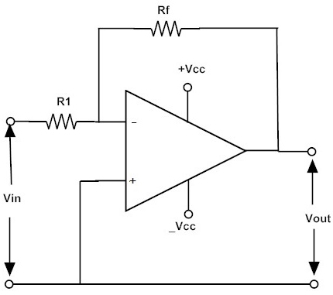
The input and output voltages can be calculated as,
Vin = I.R1​ and Vout = -I.Rf
The closed-loop voltage gain is ACL = Vout / Vin = -I.Rf / I.R1​

- A delayed switch off system

The delayed switch-off (delay-on-break) function uses a switch instead of input voltage. When the switch is turned off, the relay remains on for a programmed amount of time before turning off. For example, a projector’s light is turned off with a switch, but its cooling fan continues to run for a set time.

